**Depression**

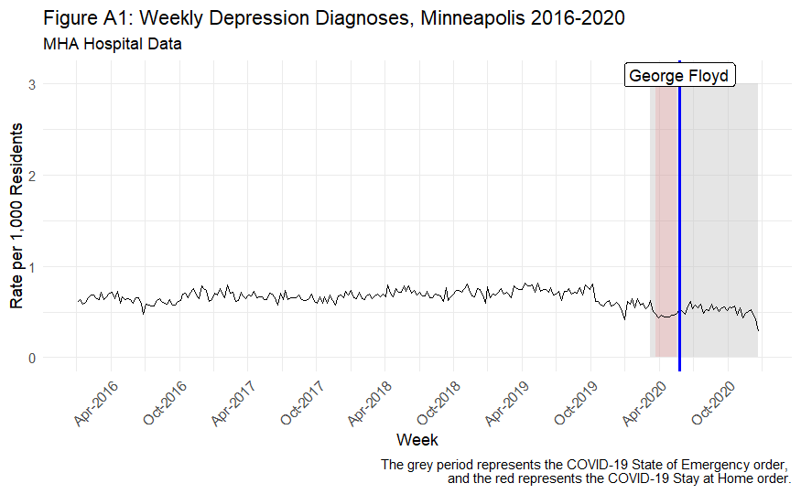

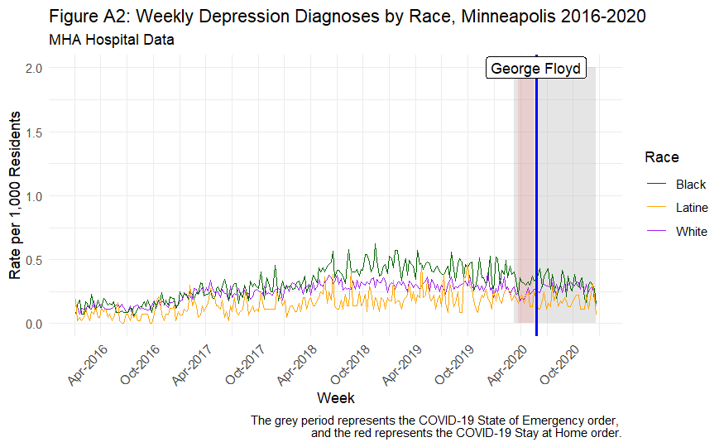

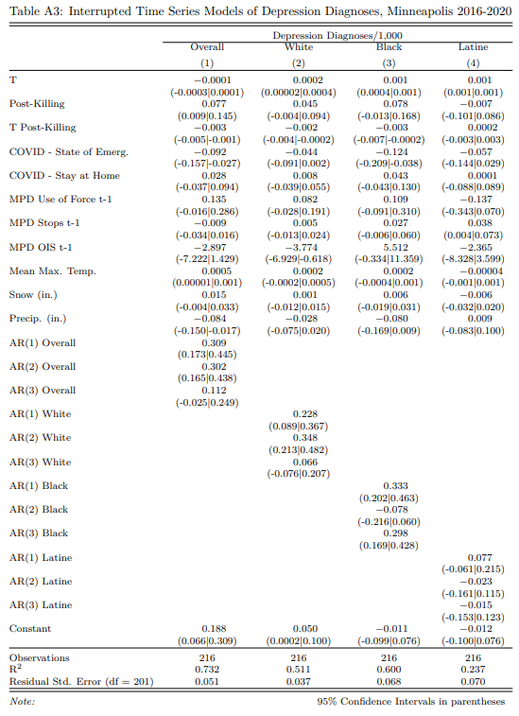

The magnitude of the depression increase (.077) is lower than the overall increase (.152) but is statistically significant. The increase for Black residents is larger than the increase for White residents, but the difference between race subgroups is not as great as in the primary specifications. The RE models also show a generally similar pattern to the primary specifications, albeit with a much larger post-killing effect in the Latine model. The CD interaction is null in the depression model for White residents.

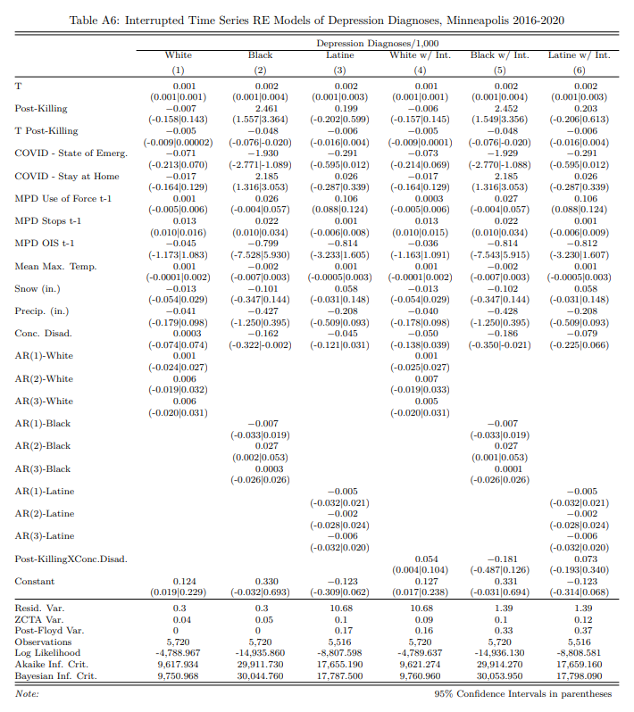

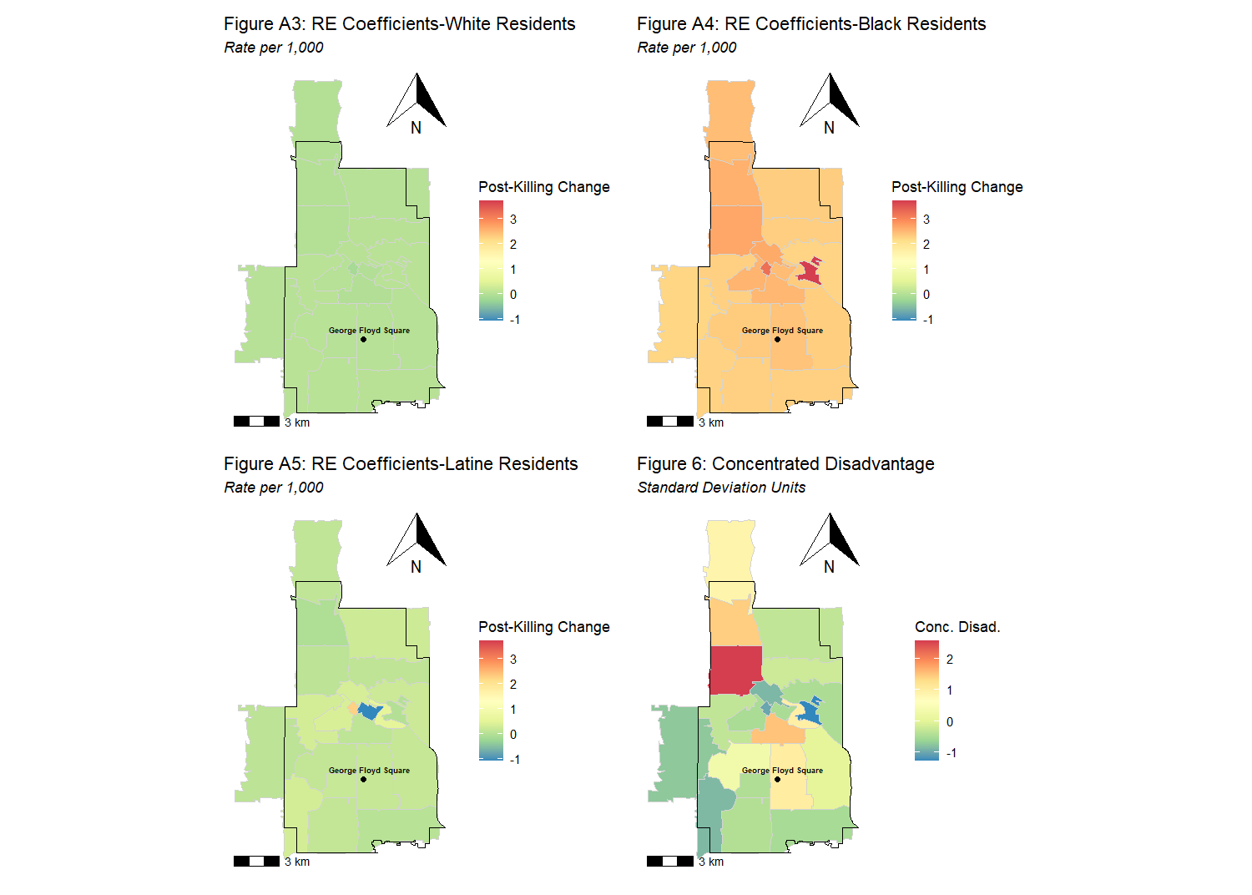

**Anxiety**

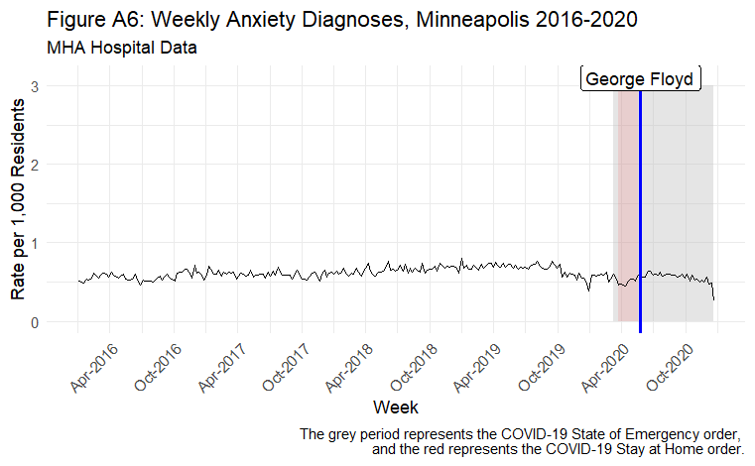

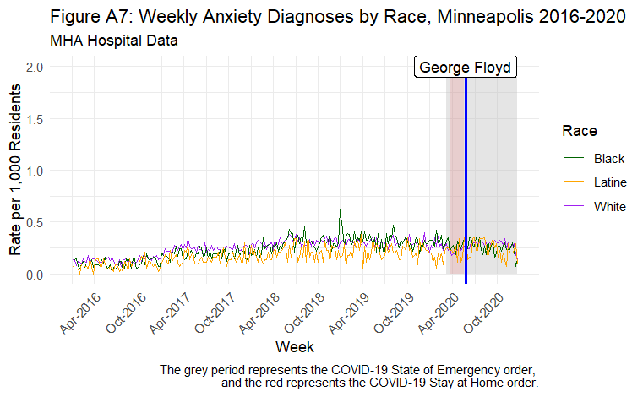

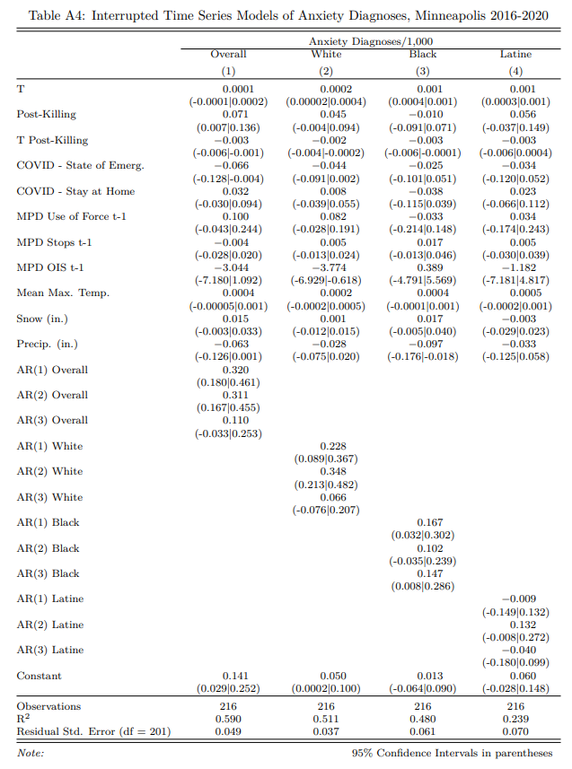

Although the primary anxiety specification’s post-killing effect is statistically significant, the racial subgroup models do not exhibit a similar pattern to the primary specifications. Similarly, the RE models show little impact on anxiety diagnoses, although it is consistent with the primary specifications in that the increase was greater for White residents in space of disadvantage, and the small anxiety increase for Black residents does not vary by disadvantage.

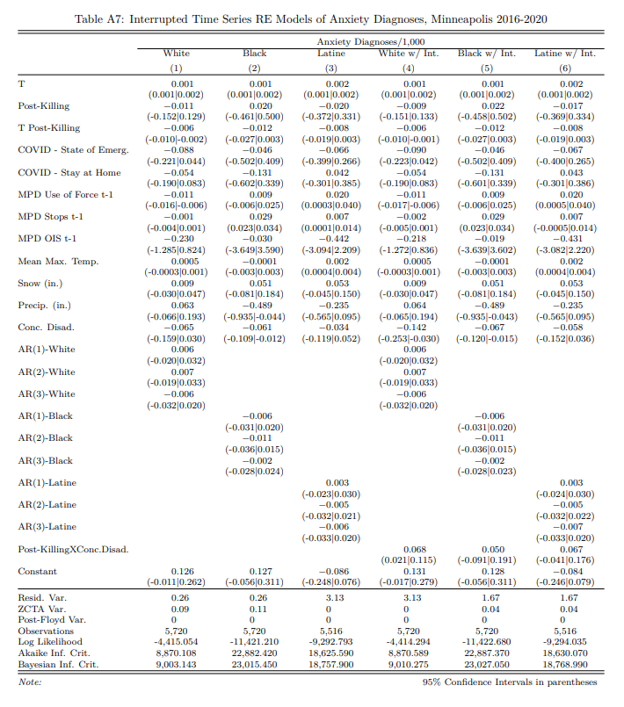

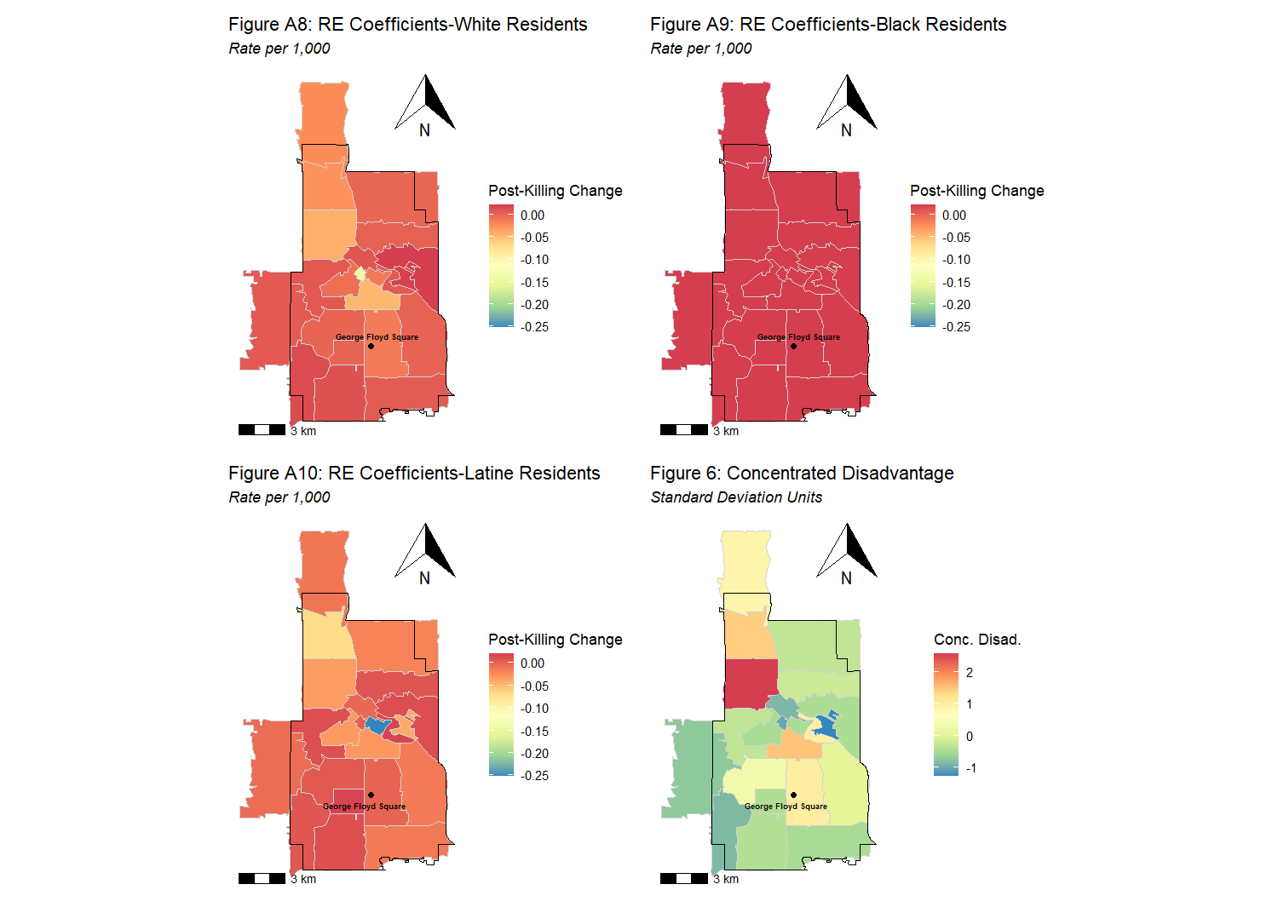

**Alcohol**

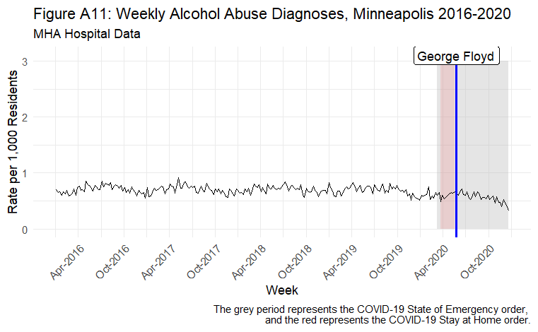

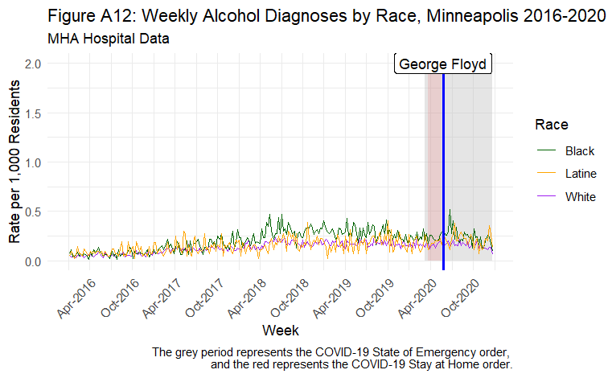

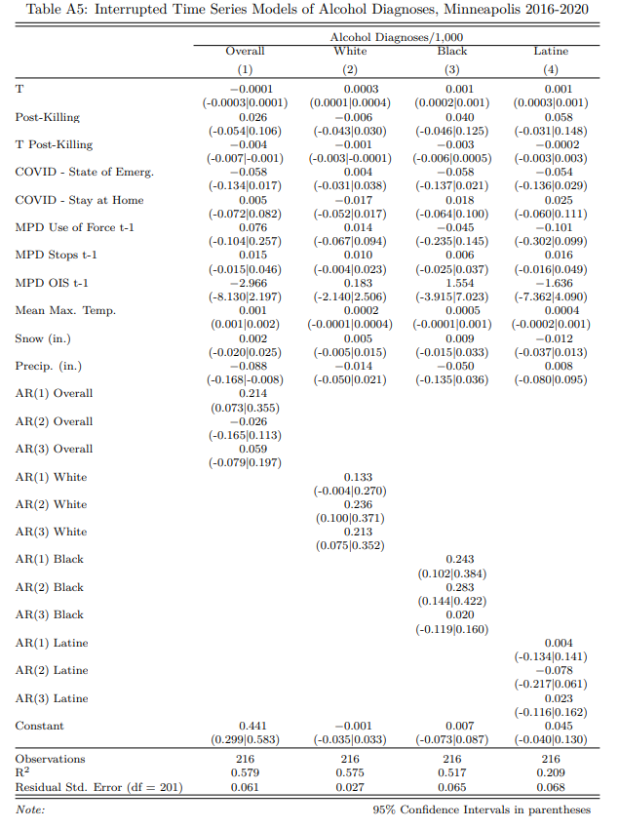

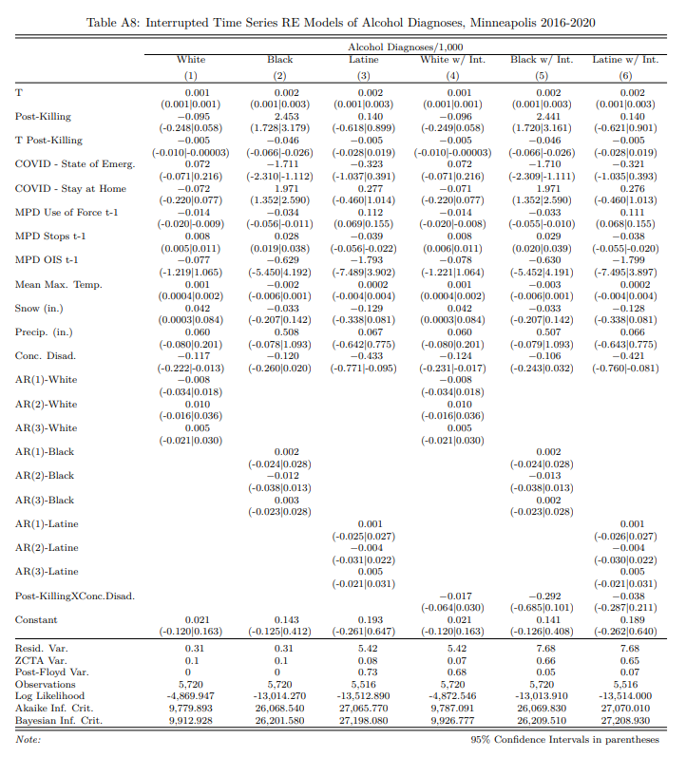

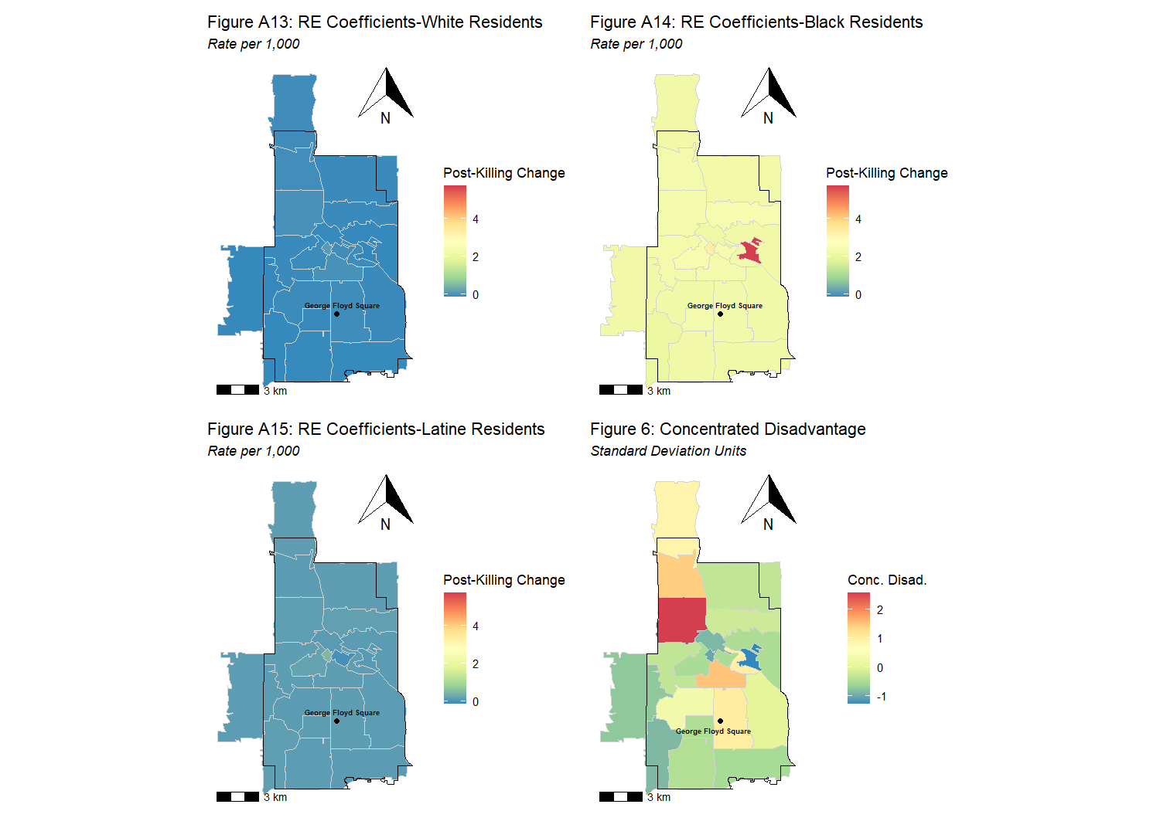

**Chronic**

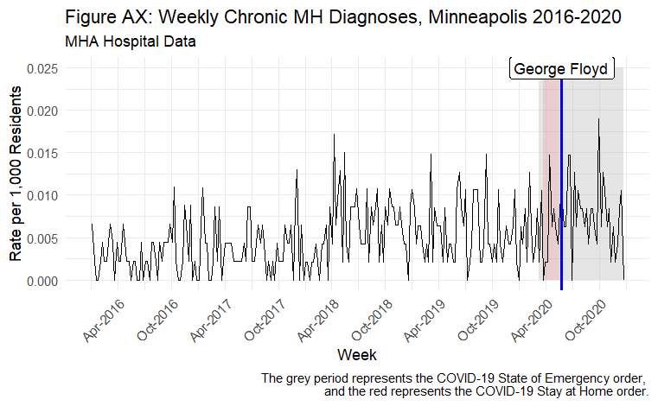

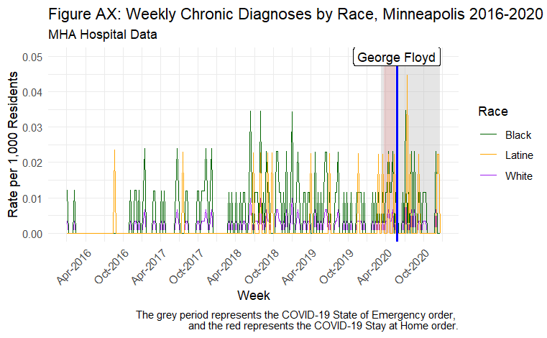

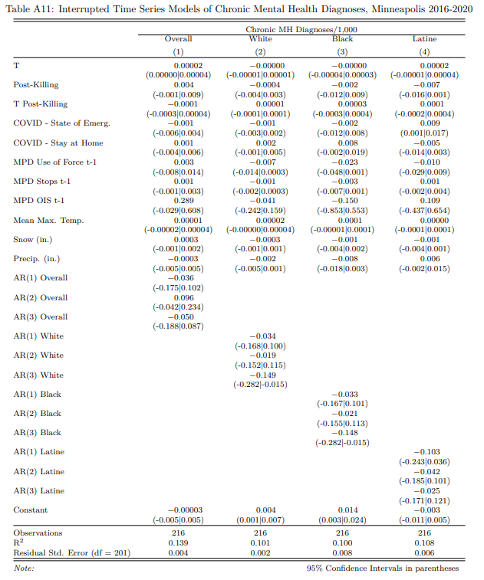

Chronic MH diagnoses are far less frequent (as they are just coded for a subset of MH diagnoses). The overall ITS specifications do not show any increase in Chronic MH diagnoses. The RE specifications corroborate this lack of impact.

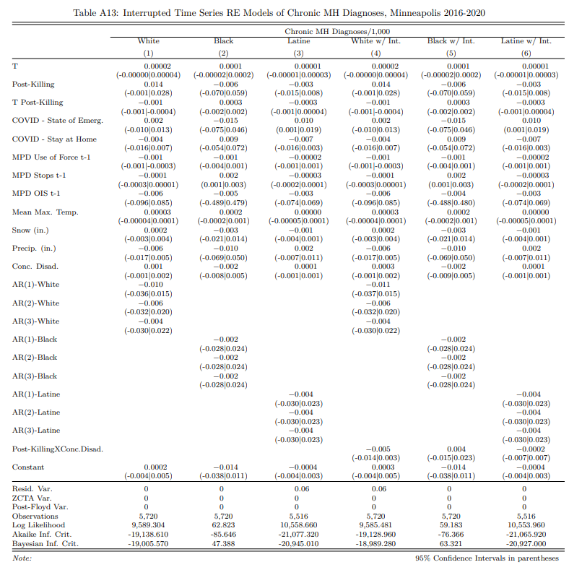

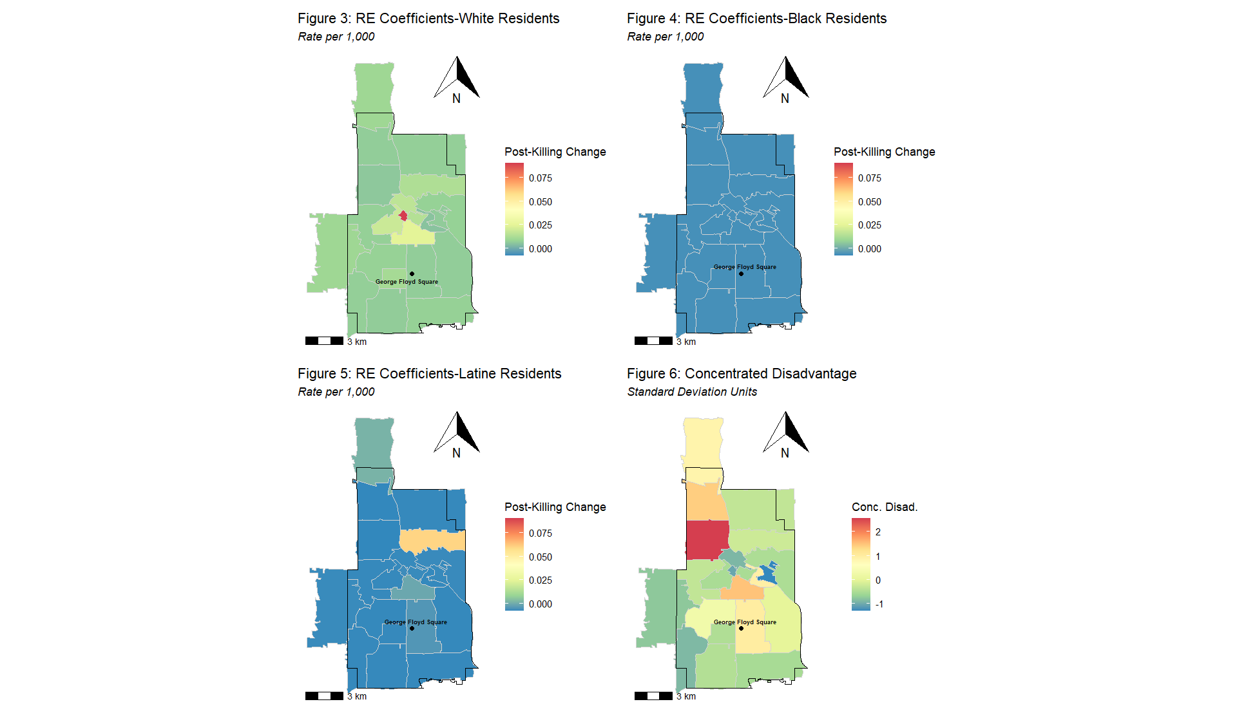

**Acute**

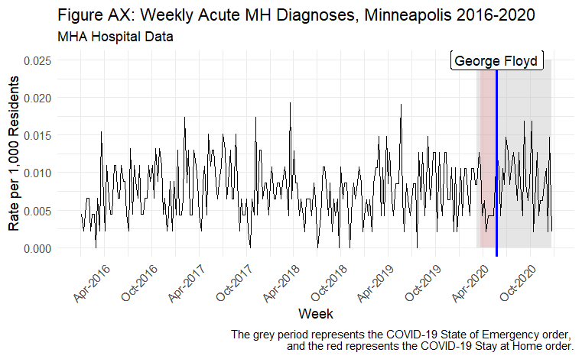

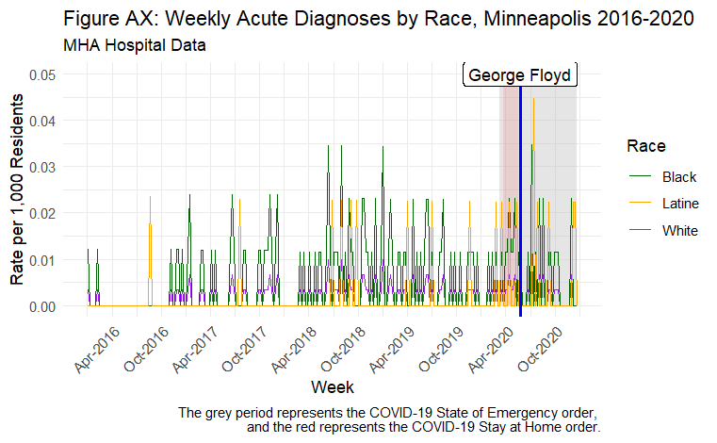

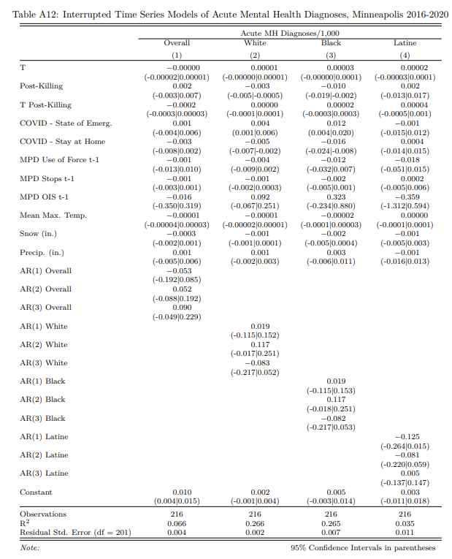

Similar to the chronic models, the acute overall ITS and RE models do not show any increase in acute MH incidence. In sum the chronic and acute indicators are very infrequent and do not appreciably change from baseline levels post-killing. IMO, we have limited ability to measure acute vs. chronic MH diagnoses given the limited diagnoses for which these codes exist.

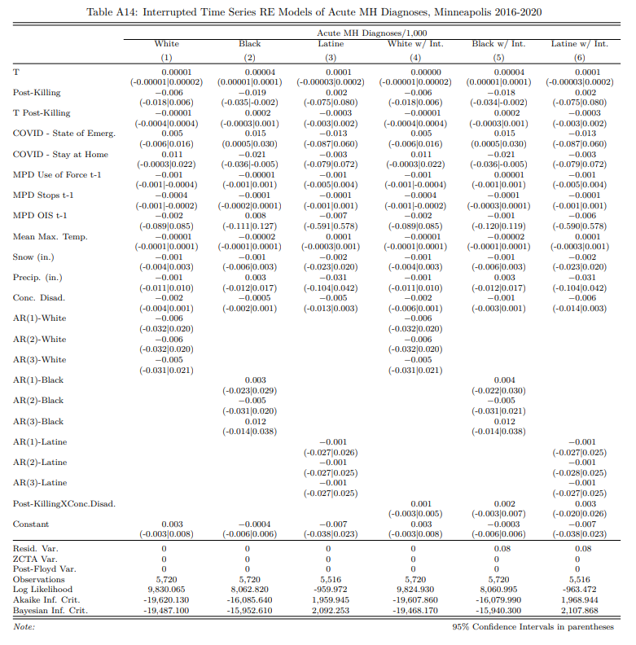

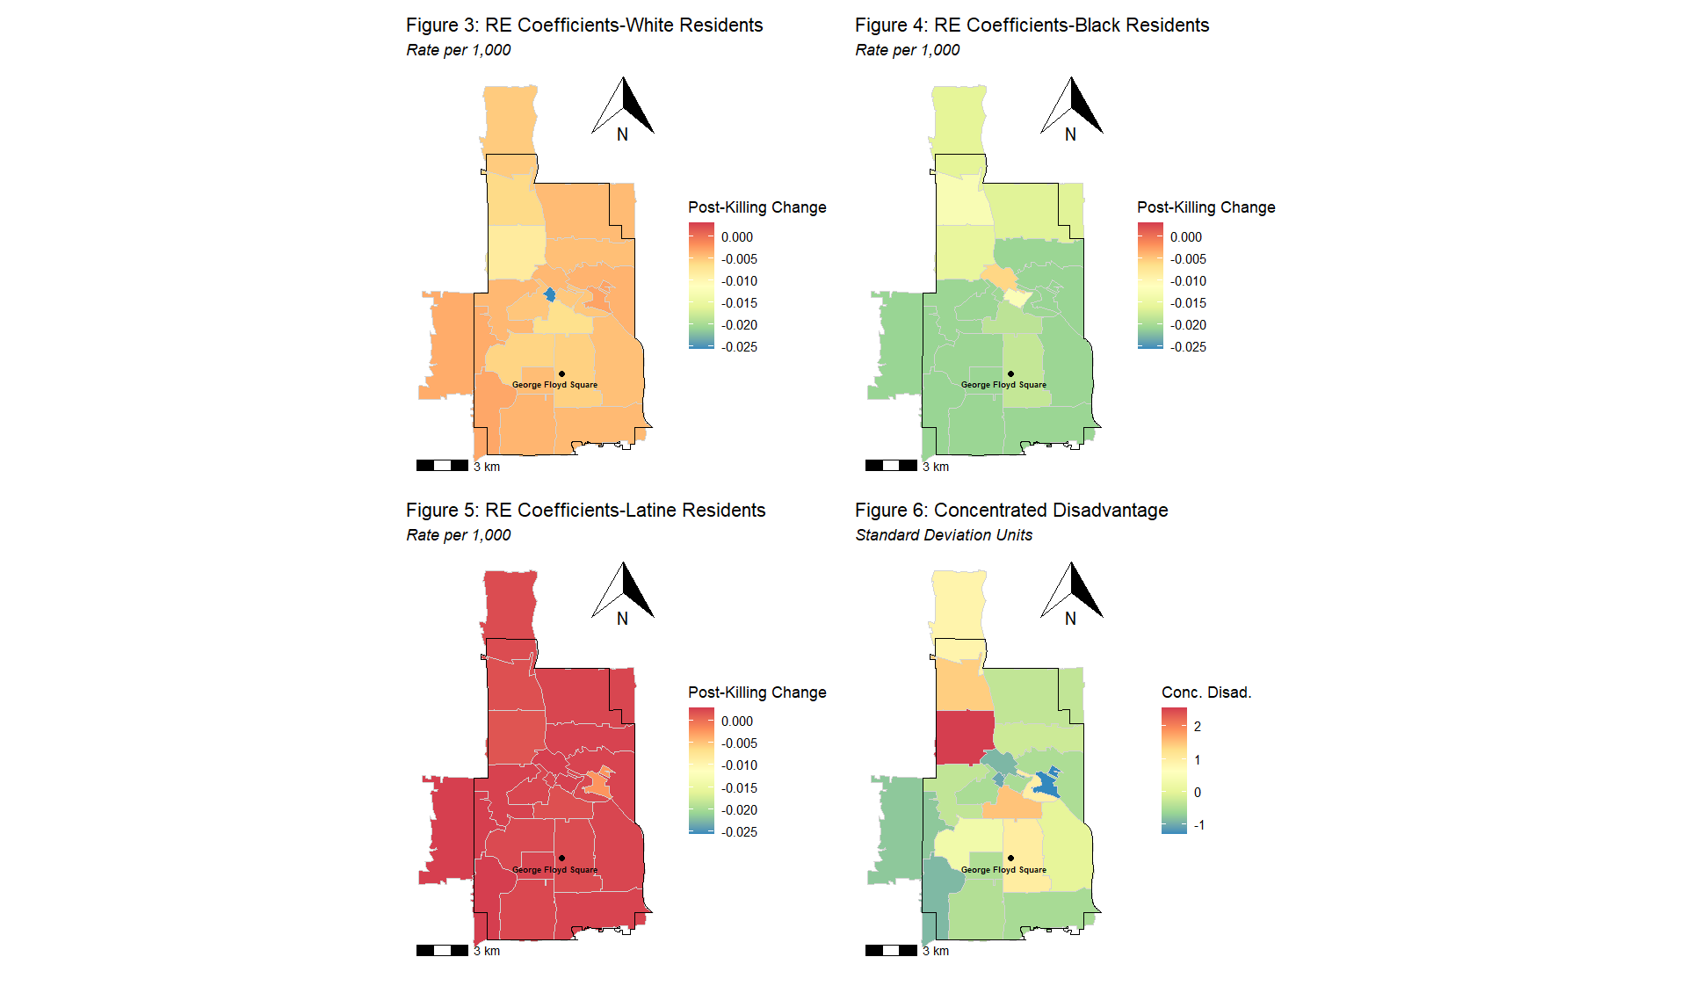

**Primary Specifications w/ Nonlinear Time Trends**

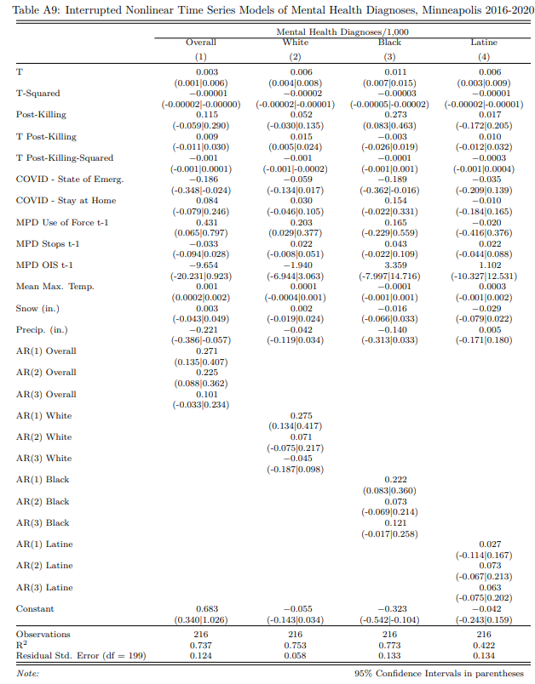

Our primary specifications are robust to nonlinear trends in both the pre- and posttreatment periods. The increase for Black residents is modestly increased, and the others are relatively similar. The RE models w/ nonlinear trends tell a very similar story to the primary RE specifications, and the interaction terms are nearly identical.

